SOLUCION DE PRUEBA

2.

URL : <https://github.com/DianaCarvajal24/Prueba_Diana_Carvajal>

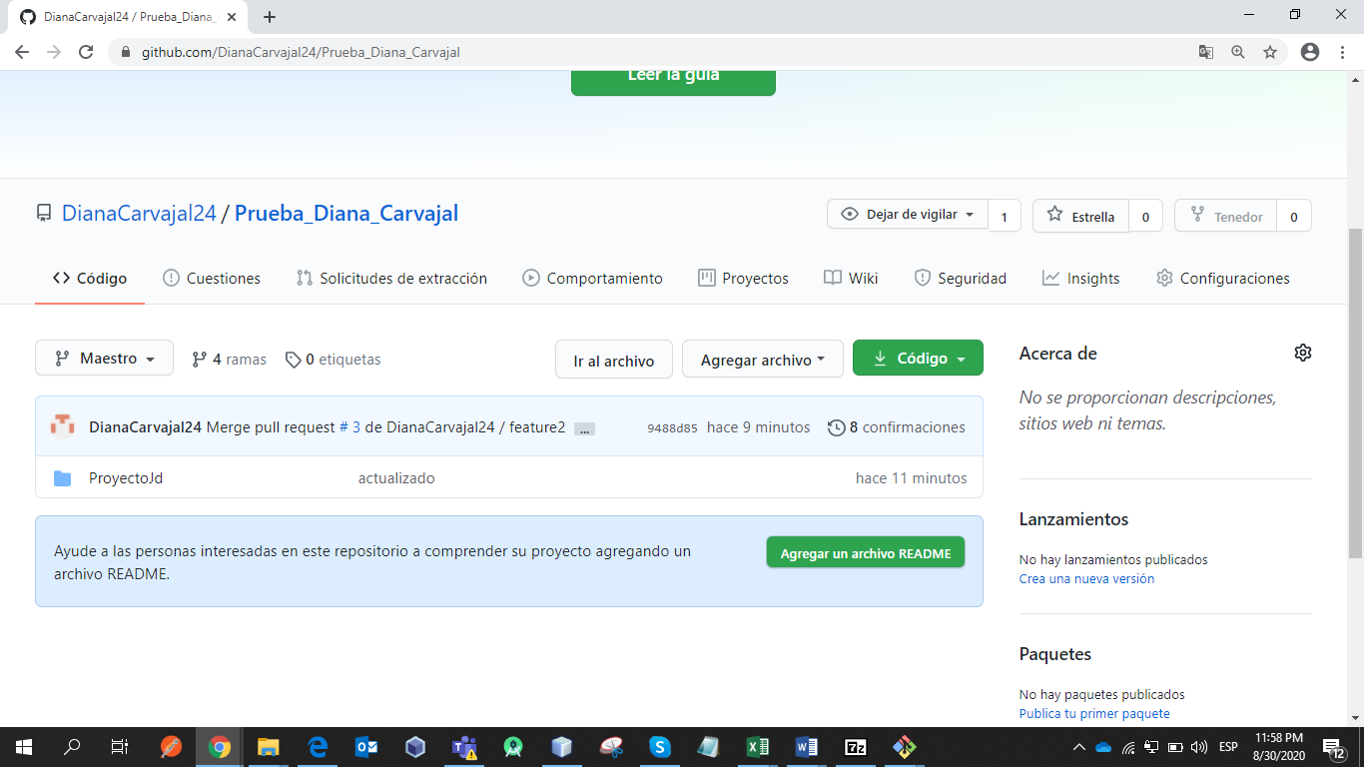

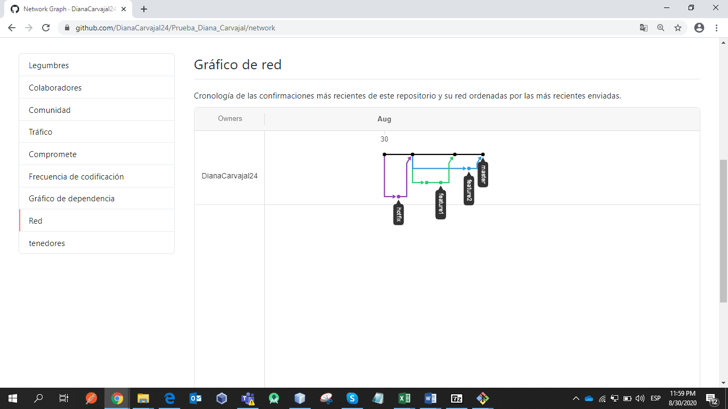

3.

CLOUD

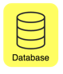

http://puerto:ip/servi

SERVICES

SERVICES

SERVICES